

Information Systems Engineering Department   
 ORT Braude College

Capstone Project Phase A – 61998

**Preliminary diagnosis of Alzheimer’s**

**using Virtual Reality**

**24-1-D-17**

**Advisors:**

Dr.Anat Dahan

Dr.Marcela Viviana Karpuj

**Writers:**

Tali Azoulay - Tali.Muchnik@e.braude.ac.il

Aviv Ben Ezra – Aviv.Ben.Ezra@e.braude.ac.il

Table Of Content

Abstract 2

Introduction 3

Theoretical Background 5

Related Work 8

Expected Achievements 10

Engineering Process 11

Product 12

Product Description 13

Measured Variables 17

Criteria for the success 17

System Requirements 18

Functional Requirements 19

Non - functional Requirements 19

Diagrams 19

Use Case Diagram 20

Activity Diagram 20

Sequence Diagram 21

System Architecture 22

The VR application 24

Input Output Tests 26

System check 27

References 28

# Abstract

Alzheimer's disease (AD) presents a worldwide challenge, impairing patients' ability to perform routine functions and take a high emotional cost. Early diagnosis is important for the medical community, as it delays the progression of the disease. Additionally, distinguishing Alzheimer's from other types of dementia poses a significant obstacle due to shared symptoms yet differing treatment strategies.

Currently, diagnostic procedures involve various tests aimed at assessing the subject's cognitive abilities and daily functioning. Navigation, a pivotal measure in this assessment, is particularly challenging to assess in clinical environments.

Technological advancements have opened new possibilities, such as Virtual Reality (VR). One proven test is the supermarket virtual reality (VST) test, which assesses navigation skills that could assist in diagnosing Alzheimer's disease (AD). However, hospitals have avoided using the test due to space limitations. This project aims to adapt the VST for Israeli hospitals, addressing specific needs such as time limitations, the use of Israeli products, and personalization.

The system will provide a recommendation on the likelihood of Alzheimer's disease (AD) based on the subject's performance in the VR test. Additionally, we plan to validate the system by comparing the performance of individuals with AD to that of healthy control subjects.

The project aims to make contributions to both the medical community and the elderly population, particularly the elderly who are most affected by AD.

# Introduction

Dementia represents a significant public health challenge globally, with profound implications for affected individuals, their families, and healthcare systems. According to recent studies published in reputable academic journals, dementia is characterized by a progressive decline in cognitive function, impacting memory, reasoning, language, and the ability to perform daily activities [1].

The prevalence of dementia is projected to rise substantially in the coming decades due to aging populations and increasing life expectancy. Consequently, dementia represents a significant socioeconomic burden [2-3].

Dementia is a group of diseases. Within the group there are other types of dementia which are also divided into further subtypes. AD is the most prevalent subtype, accounting for approximately 60-70% of dementia cases. Other common types include vascular dementia, and Lewy body dementia. Therefore, there should be a differential diagnosis and treatment for each subtype [4-5].

AD is characterized by memory loss, confusion, impaired judgment, and difficulties with spatial navigation, primarily due to molecular changes like beta-amyloid plaques and tau tangles. These changes cause atrophy in the hippocampus and entorhinal cortex, located in the brain's medial temporal lobe, it means the disease leads to the shrinking of critical brain regions responsible for memory and navigation. Among its various subtypes, AD is the most prevalent, distinguished by its specific pathological and symptomatic manifestations.

Diagnosing AD is crucial because it has significant emotional and legal implications. When a parent or loved one is diagnosed and their daily challenges are identified and named, it brings great relief. Recognition and diagnosis are important for both AD patients and their families, providing clarity and support. To understand the emotional and empathic level, in this work, we interview a person whose mother was diagnosed with AD. This aspect is crucial as it delves into the immediate and evolving emotional landscape that family members navigate post-diagnosis.

Each clinic performs a series of tests differently according to the constraints of the clinic. However, all clinics perform a series of tests. This method faces numerous challenges. Firstly, unlike some medical scenarios, it doesn't yield clear-cut results, necessitating thoughtful consideration and discretion from the doctor each time. Moreover, these tests often face challenges in accurately simulating real-life scenarios within clinic settings, particularly in terms of time constraints. Consequently, a wide array of tests must be conducted. Moreover, certain tests, such as the spatial navigation, demand resources that clinics often lack, leading to their abandonment. For instance, personnel and specific routes are essential for the navigation test.

AD is a disease that affects not only the patient but also their family, making it crucial to effectively manage the condition by understanding the current situation, anticipating future developments, and preparing accordingly. Seeking assistance and initiating legal procedures become essential steps in this process. The primary challenge lies in raising awareness and helping relatives of the diagnosed person understand that the individual may no longer be capable of making decisions independently. This insight is based on an interview with Maya Tzadok, a medical student specializing in dementia at Tel Aviv University.

Our project aims to develop a diagnostic solution that leverages the capabilities of VR to simulate real-world scenarios. The system aims to test patients' cognitive abilities through a gaming platform. There is an existing VR test called the Supermarket Virtual Test (SVT). In this simulated experience, the subject replicates a route that is shown in a short video clip. The test assessed their spatial navigation and memory. This comprehensive approach aims to provide a detailed assessment of cognitive functions for early diagnosis and differentiation of AD.

Our system meets Carmel Hospital's time limitations and is designed to simulate the Israeli environment, which is a familiar environment, making the experience more realistic for users. Additionally, the assessment is personalized to reflect the individual's routine and lifestyle. Our uniqueness lies in incorporating identification challenges that add significant value to the diagnostic process. For example, during the navigation task, sudden tasks such as answering a phone when it rings will be introduced. The subject will then need to recognize and name a family member whose image appears. This approach not only tests memory recall and recognition skills in a personalized context but also evaluates how well the subject can maintain focus on the primary navigation task after a potentially emotionally impactful interruption.

In conclusion, AD, the most prevalent form of dementia, is characterized by cognitive decline due to brain changes. Early diagnosis is crucial for effective management and support. Our VR-based diagnostic system enhances assessment by simulating real-world scenarios and incorporating unexpected identification tasks, providing a comprehensive evaluation of cognitive functions for early diagnosis and differentiation of AD.

# Theoretical Background

Currently, AD has no cure, and there are no medications that can stop its progression. However, drugs have been licensed to help manage symptoms and temporarily reduce their progression in some people. Two types of drugs are currently used to treat symptoms: cholinesterase inhibitors and memantine (Namenda). These are usually the first medicines tried, and most people see modest improvements in symptoms. These treatments can help patients maintain cognitive function and manage behavioral symptoms for a longer time [6].

AD significantly impacts spatial navigation abilities due to molecular changes that cause atrophy in critical brain regions. Beta-amyloid plaques and tau tangles lead to the degeneration of the hippocampus and basal forebrain (BF), areas essential for allocentric navigation strategies, which rely on environmental cues and are heavily dependent on these structures. AD patients increasingly adopt egocentric navigation strategies, making the evaluation of these strategies through real-space tasks and VR-based systems crucial for early diagnosis and differentiation of the disease [7].

The challenges of diagnosing dementia, particularly AD, in its early stages are significant and multifaceted. Early diagnosis is crucial because it allows for timely interventions that can help manage symptoms, reduce the progression rate, and improve the quality of life for patients and their families[7].

According to the World Health Organization, The following information is mentioned in the paper by Fernandez Montenegro and Argyriou (2017) : “by 2030, 1.37% of all deaths worldwide will be due to AD disease and other forms of dementia. On average, individuals with moderate dementia live for about 8 years after their diagnosis”. By the time Alzheimer’s disease is diagnosed, the damage to brain cells is usually so advanced that it cannot be undone. Unlike other cells in the body, brain cells do not regenerate once they are destroyed. This is why it's crucial to detect dementia early to slow down the progression of the disease [8].

Presently, diagnosing AD requires subjects to undergo a series of tests aimed at uncovering potential cognitive impairments and disruptions in daily functioning. In practice, a medical professional evaluates the individual and presents a suite of results to the doctor. The doctor then pieces together the diagnostic puzzle and determines the next steps. While additional tests like brain imaging exist, they primarily detect AD in its later stages. As emphasized, early identification of dementia-related illnesses is crucial.

To understand the emotional impact of Alzheimer's disease, we conducted an interview with Or Abramson regarding his mother's diagnosis at age 66. Or's initial reaction was characterized by shock and sadness, finding the situation difficult to digest and feeling emotionally suppressed. However, post-diagnosis, the relationship between Or and his mother improved, becoming more empathetic with increased communication. To cope, Or emphasizes maintaining a normal daily routine and not overly focusing on the condition to keep life as usual. Significant daily life changes include a decrease in communication, occasional confusion with names and objects, and difficulty in expressing thoughts clearly. Personally, Or strives to remain optimistic, spending as much time as possible with his mother and not dwelling on future uncertainties.

His mother's treatment involves using a hormonal patch and medications, with the diagnosis process including cognitive tests, memory games, and mathematical tasks in a clinical setting. Or believes his mother might be willing to use VR diagnostics in a virtual supermarket environment, designed to simulate a realistic shopping scenario, given her enjoyment of shopping at supermarkets. This interview summary Or Abramson's experience following his mother's Alzheimer's diagnosis reflects both personal and clinical dimensions of dealing with AD.

On March 11th, 2024, another interview was conducted with Dr. Spector, a dementia specialist at Carmel Hospital in Haifa, who outlined the diagnostic procedures employed at the facility. The current method for diagnosing Alzheimer's disease (AD) primarily involves a questionnaire assessing environmental awareness and a memory test, with individuals suspected of having AD undergoing CT or MRI brain mapping tests. Dr. Spector noted that in Alzheimer's, memory impairment occurs early in the disease process, contrasting with other forms of dementia where cognitive function is affected first. Therefore, assessing visual memory is deemed effective for early Alzheimer's diagnosis, while orientation testing remains challenging due to hospital conditions. Dr. Spector highlighted the limitations of the hospital's resources and requested that examinations be completed within five minutes.

According to Dr. Spector, the current method for identifying Alzheimer involves primarily a questionnaire assessing awareness of the environment. Additionally, a visual memory test. If there are any suspicions, the individual undergoes CT or MRI brain mapping tests. Dr. Spector is a dementia specialist at Carmel Hospital in Haifa. Dr. Spector also explained that in AD evaluating orientation is valuable, although challenging due to current hospital conditions. Orientation assessment involves determining the patient's awareness of time, place, and person, which is crucial for diagnosing and understanding the progression of AD. Therefore, solutions like VR simulations that replicate real-world environments are being explored to provide a more accurate and controlled setting for assessing orientation and other cognitive functions in AD patients.

Spatial navigation decline is an early cognitive impairment in AD, leading to spatial disorientation characterized by a lack of awareness of one's location and difficulty navigating. Spatial navigation impairments typically appear in the mild cognitive impairment (MCI) stage, progressing into the early stages of Alzheimer's disease dementia. The average age of onset for spatial navigation difficulties in AD patients is around 70 years. This results in navigation errors, even in familiar environments. Studies suggest up to 70% of AD patients experience getting lost, with around 40,000 patients in the UK experiencing their first episode yearly. With the global dementia population increasing, these numbers are expected to rise [9].

In recent years, VR has emerged as a promising tool for cognitive assessment. This is due to the fact that modern VR graphics and processing speeds are capable of providing subjects with a highly realistic experience. The VR offers immersive and friendly testing environments [10].

VR uses computer simulation to replace an individual’s external sensory world with an artificial environment that updates corresponding to an individual’s orientation and physical movement. VR can be generated using either a Head Mounted Display (HMD) or a cave system.

In addition to HMD,the cave system also displays VR environment. The cave system offers a significantly more immersive experience by projecting virtual environments onto multiple walls. The cave system is considered to be better and more expensive. However, despite the mentioned drawbacks, HMDs still yield promising results. Their favorability stems from their lower cost and space requirements. That allows us to testing the traditional factors to diagnose dementia: memory, executive function, navigation, and motoric skills.

VR offers numerous advantages. Firstly, it eliminates space constraints, allowing navigation tasks to be conducted simply by wearing VR glasses. In contrast, traditional methods required medical personnel to arrange a specific route and assemble a team for examination. Additionally, traditional tests can induce stress and fear, whereas VR glasses provide a more enjoyable and less intimidating experience.

In summary, AD lacks a cure and its prevalence continues to grow. However, early diagnosis is crucial for effective treatment and patient handling. Despite advancements in medical technology, diagnosing dementia in its early stages remains challenging. Early detection is vital. Presently, the preliminary are not sufficiently precise and there is a necessity for improved diagnostic methods. VR seeks to enhance assessment by providing enjoyable testing experiences with fewer resource constraints, offering a promising alternative to traditional methods.

# Related Work

This chapter review other papers. The Virtual Supermarket Test (VST) is a good tool for evaluating spatial navigation, assessing both egocentric and allocentric orientation. Recent studies show significant impairments in Alzheimer's patients compared to controls, highlighting its diagnostic potential. However, challenges exist, particularly with older users struggling with VR glasses. Additionally, simulating foreign supermarket layouts may compromise test realism, impacting results.

The VST is a spatial navigation assessment that evaluates egocentric and allocentric orientation. Participant require watch 14 videos on an iPad, each depicting a shopping trolley navigating through a virtual supermarket from a first-person perspective. The environment lacks distinctive landmarks, focusing solely on navigation abilities. Participants answer questions after each video to gauge their understanding of their own position, the layout of the supermarket, and their direction. This test has been utilized in previous studies to identify navigation difficulties in patients with Alzheimer's disease, and its relationship with real-world spatial disorientation is being explored [9].

In line with the hypothesis, the study found that AD patients exhibited impairments in all aspects of the VST compared to controls. [9] Other study show that the VST, unaffected by factors such as age, education level, and diagnosis of mild cognitive impairment. These results underscore the importance of conducting further, more comprehensive assessments of the usability of the VST [12].

In other test participants were instructed to familiarize themselves with the joystick and the HMD by navigating through a controlled virtual. The practice session typically lasted between 5 to 10 minutes, varying based on the time it took for participants to proficiently reach a designated building within the controlled environment. [13] In simpler terms, the test demonstrates that the participants are quite adept at navigating with the technology.

The study revealed that AD patients demonstrated significantly poor time performance in compare to the control group. Additionally, it was noted that AD patients were prone to collisions with objects and exhibited difficulty recognizing large objects, like buildings, that were not previously encountered along the same trajectory.

One of the VST test encompassed 58 dementia patients, including those diagnosed with Alzheimer's disease. The study successfully distinguished between Alzheimer's patients and healthy individuals, as well as between Alzheimer's patients and other dementia patients [14].

Limitations:

Majority of the subjects are old individuals. However, it may pose challenges for them to use VR glasses due to factors such as vision impairments, and unfamiliarity with technology. Older adults may find it challenging to adjust the VR glasses properly, leading to discomfort or difficulty in viewing virtual environments. Additionally, issues such as motion sickness or disorientation may arise, further complicating the use of VR glasses for this demographic. As such, developers need to consider these limitations and make the system as user-friendly as possible. This could involve providing clear instructions and support.

The simulation of a supermarket that is based on abroad template may compromise the realism of the test. When the virtual environment does not accurately represent the local supermarkets familiar to participants, it can introduce discrepancies that affect the authenticity of the experience. Participants may encounter products, layouts, or signage that are unfamiliar to them, leading to confusion or disorientation. This lack of familiarity with the simulated environment may influence participants' navigation and decision-making processes, potentially skewing the results of the test. Therefore, it's essential for simulations to closely mirror the real-world environments that participants are accustomed to in order to maintain the validity and reliability of the assessment.

VST evaluates spatial navigation through 14 videos on an iPad, lacking landmarks, and focusing on navigation abilities. Studies demonstrate impairments in Alzheimer's patients, underscoring its diagnostic potential. However, challenges exist, including usability issues with VR glasses among older adults. Additionally, simulating foreign supermarket layouts may compromise test realism, influencing navigation accuracy.

Given that VR supermarket navigation assessments already exist, our goal is to adapt the test to meet specific requirements identified during our interview with Dr. Spector. These adaptations include adjusting for time limits and incorporating culturally relevant elements such as Israeli products and environments. Additionally, we aim to enhance the diagnostic value by adding personalization features that simulate real-life scenarios closely. Unlike the existing VST, our system will integrate unexpected identification tasks, such as recognizing and naming a family member during the navigation task, and will minimize the number of questions to reduce patient anxiety. This approach not only assesses spatial navigation but also evaluates memory recall and the ability to handle cognitive interruptions, making the test more realistic and less stressful for the patient.

# Expected Achievements

The system's objective is to identify AD in its early stages using a navigation skill and memorizing.

The system will determine whether the subject has suspected AD and will be integrated into a series of tests administered by the medical team.

Our goal is to adapt and enhance an existing VR-based diagnostic system to meet the specific needs identified in our recent interviews, such as time limitations, personalization, and realistic environments. Initially, our VR-based diagnostic system will be tested by our team to ensure it is suited for healthy individuals. Following this calibration, the system will be evaluated on Alzheimer's patients at various stages of the disease. Additionally, we will include control groups comprising patients with other neurodegenerative diseases and non-affected family members, matched by age and gender. This approach will ensure the reliability and accuracy of our assessments across different populations, facilitating the early diagnosis and differentiation of Alzheimer's disease.

The system will prompt the tested individual to undertake a navigation test utilizing virtual reality through Oculus. The test will involve guiding the patient through a virtual supermarket, after which they will be asked to replicate the route. The test will be time-limited to ensure efficiency and accuracy.

Our uniqueness lies in incorporating identification challenges that add significant value to the diagnostic process for the subject, such as the sudden appearance of a family member's image during the navigation task. The subject will be required to recognize and name the family member, which not only tests memory recall but also assesses the subject's ability to continue navigating after this cognitive interruption. This approach not only assesses the subject's memory and recognition skills but also evaluates how well they can maintain focus on a primary navigation task after a potentially emotionally impactful interruption.

# Engineering Process

Initially, we familiarized ourselves with the harsh reality surrounding dementia. We strictly stood the distinct characteristics and various forms of the condition. Along the study, we found guidance from our instructors- Anat and Marcela whose helped us focus the crucial aspects.

Furthermore, we sought out experts for consultation, specifically focusing on Alzheimer's disease. This decision was influenced by an interview with Dr. Spector, a dementia specialist. Dr. Spector's insights aided us focus on Alzheimer's disease and bind between Alzheimer's disease and VR.

Now equipped with a thorough understanding of the area, we enable to formulate the system's requirements, we are prepared to progress towards implementation. It's time to translate our knowledge into action and devise strategies for effective execution. Our next chapter is to learn about programming with virtual reality.

Seeking expertise from professionals in the field, such as instructors and specialists like Dr. Spector, offers several motivations is mainly Validation and Assurance. This can boost confidence and ensure that efforts are directed towards meaningful and impactful interventions.

In the future we would like to personalize the system. We would add Pictures of family members will be included in the element of surprise, and the subject will have to respond to whether he is a family member and identify Who is he. Or not as a question that appears on the screen.

The development process must address various challenges. Firstly, there's the time constraint specified by Dr. Spector, who requested that the subject test be limited to up to 10 minutes. Another challenge is the limited timeframe of one semester allocated for system development. Additionally, there's the requirement to conduct comprehensive testing of the system with verified Alzheimer's patients.

Compared to existing VR tests for preliminary Alzheimer's disease diagnosis, our test aims to be shorter. Additionally, it proposes personalized features for better suitability.

# Product

## Product Description

Alzheimer's disease harms the daily functioning and currently lacks a cure. However, with proper care, its progression can be slowed. Despite advancements in technology, the medical field still faces challenges in accurately detecting Alzheimer's and distinguishing it from other forms of dementia, making it a significant area of concern.

Numerous tests aim to identify Alzheimer's, collectively providing sufficient information for doctors to diagnose the illness. One such test involves assessing navigation skills, which serves as indicator of the disease. However, many hospitals struggle to perform this test inside their clinics. Therefore, our system aims to offer additional testing capabilities.

After our research, we found that using familiar environments like Supermarkets, has proven effective in differentiating between Alzheimer's patients, healthy controls, and patients with other types of dementia. Using a virtual supermarket allows for the simulation of common tasks that require cognitive skills, such as spatial navigation, memory, and decision-making.

The system involves two users: the subject undergoing the test and the operator overseeing the process. The operator carries out administrative tasks and provides assistance and guidance to the subject. The test, lasting approximately seven minutes as per Dr. Spetor's requirement conduct in a virtual supermarket, comprises three main components: simulation, viewing a brief video, and navigation tasks. During the test, the subject watches a video demonstrating a specific route and is then asked to walk the same path.

At the beginning, the subject is prompted to engage in a simulation. This exercise aims to familiarize the participant with the system and acclimate to the Oculus. Meanwhile, the operator registers the subject's information. This phase lasts for one minute.



Figure 1 : Virtual Super Market environment

Following the simulation, the subject receives instructions, which may be presented through reading, video demonstration, or audio. The operator ensures the subject comprehends the instructions and addresses any questions before starting the examination. This phase spans 30 seconds.

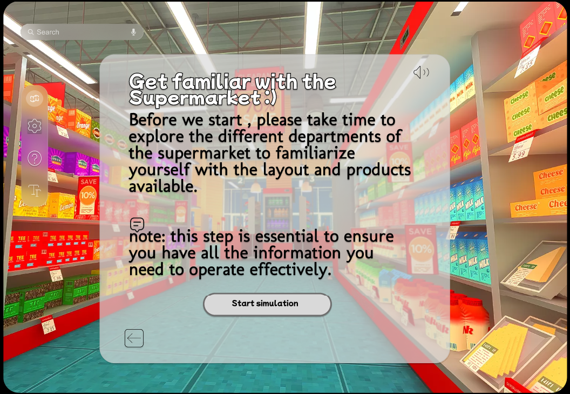  
Figure 2: Simulation Stage

finally, the subject views a brief video which display a route and a product picking. After that, the subject is tasked with restoring the route and selecting a product from the shelves.

.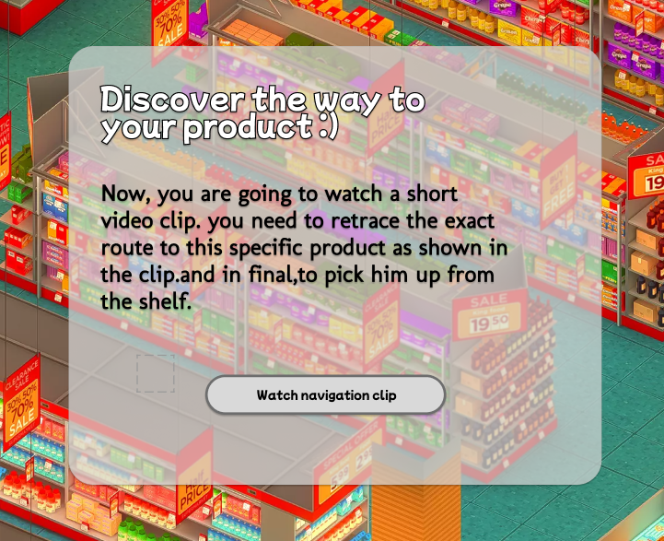

Figure 3: Navigation Clip Message Which the Subject Needs to memorize and retrace

Throughout the test, the subject must also respond to a mock smartphone retrieved from their pocket. The smartphone displays photos, and the subject is instructed to answer the phone and name the relative if which displayed.

This segment of the examination lasts for five minutes.

In the final phase of the process, the operator will extract a CSV file containing the results of the measured variables assessed during the testing phase. These results will then be analyzed by a medical professional who will formulate a conclusion based on the data obtained. This comprehensive analysis is essential for accurately interpreting the cognitive performance metrics gathered during the virtual reality simulation, enabling informed clinical decision-making.

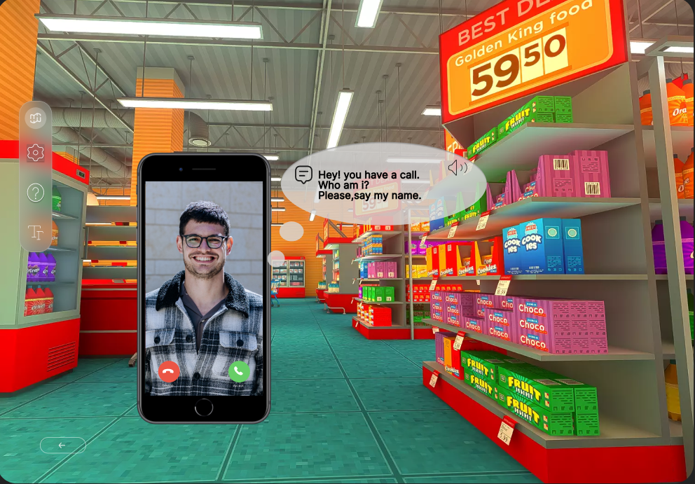Figure 4: Identification task during the test stage

The system will suggest checking the subject in specific scenarios:

* returning to the same point twice.
* the subject does not recognize a relative.
* the subject becomes confused, especially after picking up the phone.
* selecting the wrong product.

The uniqueness of the product lies in its ability to combine daily functions with regular interruptions and personalization. It simulates an environment reflective of daily routines, allowing medical factors to be incorporated into everyday life seamlessly. In the context of personalization, the feature entails displaying a relative's photo to the subject within a virtual phone interface.

Additionally, the system's unique also in the short duration—only 5 minutes. Some clinics avoid using VR for Alzheimer's detection due to time constraints. They lack a medical factor available to dedicate an hour to a single test.

This comprehensive approach will ensure the reliability and accuracy of our assessments across different populations, facilitating early diagnosis and differentiation of Alzheimer's disease.

## Measured Variables

1. Route Replication: Assessing the subject’s ability follow the initially shown route. The system will monitor:

* Wrong turns
* Collisions with shelves or items
* Frequency of returning to the same point, indicating spatial orientation and memory issues.
* Picking a different product from the task.

1. Identification task : the ability to recognize the close relative in a screen phone during the navigation task. Monitoring:

* Correct or Incorrect identification of the relative.
* The time it takes him to identify and answer/ignore the call.

1. Task Continuation Post-Interruption: Evaluating the patient’s ability to maintain focus on the navigation task immediately after the cognitive interruption required for memory recall of identifying a close relative. monitoring:

* Trucking head movements- like sudden head turns, such as quickly spinning the head to one side.
* The time it takes to continue with the task

## Criteria for the success

* Carmel Hospital will participate a future experiment.
* A subject's test time will not be more than 5 minutes.
* Differences will be found between Alzheimer's patients and healthy subjects in the following parameters: collision with objects, navigation execution time, image recognition.
* Intuitive and easy-to-use user interface to interact with the screening in VR.
* Ensure participant privacy and data security and provide clear and thorough informed consent processes.
* Before full deployment, we will conduct pilot programs to assess the system's reliability in real-world conditions.
* The system should accurately track subject interactions and effectively extract a CSV file containing the measured variables during the test.
* The system will first be tested by a team to calibrate it for healthy individuals, after this calibration, we will test the system on AD patients at various stages of the disease.
* All participants will be matched by age and gender to ensure accurate and reliable results.

## System Requirements

### Functional Requirements

1. The system allows start test

1.1. The system offers guidance displays.

1.2. The system allows the user to start a simulation.

1.3.The system displays a navigation video clip.

1.4 The system displays the participant's family pictuers.

1.5. The system interact with mock objects.

2. The system allows users to customize their experience

2.1 The system allows users to pause.

2.2 The system allows to adjust font and size.

2.3 The system enabling voice narration.

3. The system perform data analysis.

3.1.The system generates a corresponding report.

3.2 The system presents the analysis in a CSV file.

### Non - functional Requirements

1. The system utilizes a supermarket scene.
2. The operator inputs subject serial numbr test
3. The system is usable in any location.
4. The system supports the Oculus Quest 2 version.
5. The system is implemented in C#.
6. The system stores data in a database.
7. Medical information will not be stored.
8. The system supports two languages: Hebrew and English.
9. The system will support deaf users.

## Diagrams

### Use Case Diagram

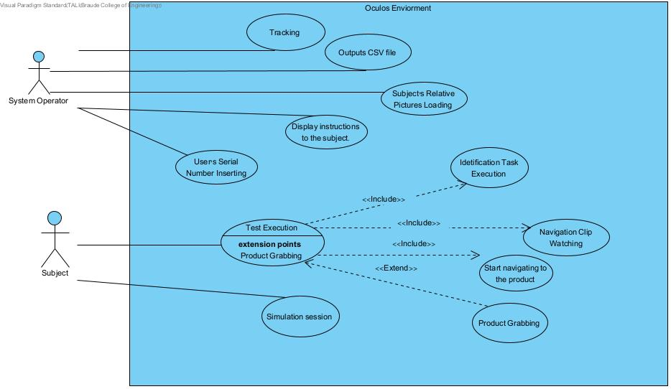Figure 5: Use Case Diagram

The use case diagram illustrates the primary functionalities of the system, aligning with Dr. Spector's requirements. Two main users are identified: the system operator and the subject. Test execution stands out as the central function, consuming the majority of the system's resources and time.

However, before the test begins, the system operator undertakes preparatory tasks such as loading pictures and inserting serial numbers.

### Activity Diagram

Figure 6: Activity Diagram

This flowchart outlines a virtual reality simulation test for diagnosing Alzheimer's disease, beginning with subject orientation and followed by a navigation task to locate a specific product. Throughout the test, subjects may receive a simulated phone call to assess their recognition and multitasking abilities. The test concludes with data collection on navigation accuracy and item selection, which are then analyzed to evaluate cognitive functions.

### Sequence Diagram

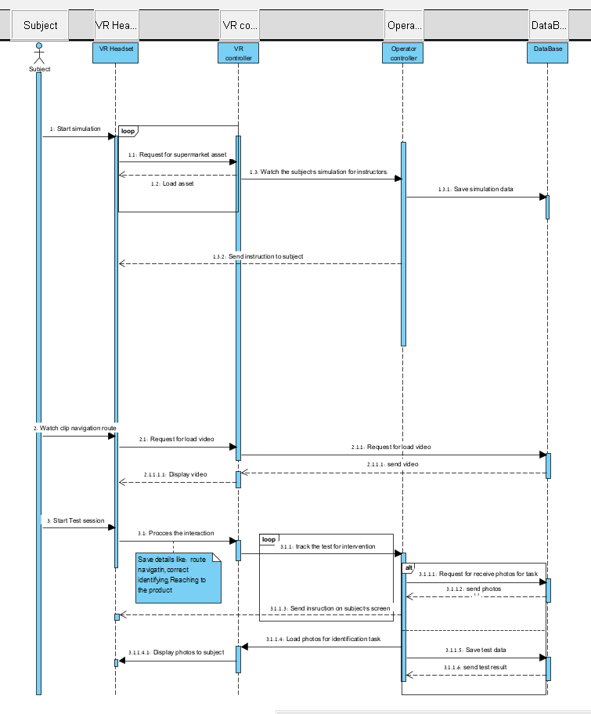Figure 7: Sequence Diagram

The sequence diagram outlines the processes and communication between the subject, VR headset, VR controller, operator, and database during a VR simulation test. This structured interaction ensures that data collected during the simulation is robust and reflective of the subject's cognitive abilities.

## System Architecture

**Architecture -**

There is a Oculus headset and a control computer. The system consists of a VR headset and a Main PC Control unit. The VR headset is primarily responsible for presenting the virtual environment and capturing user interactions. The Main PC Control manages the backend processes including test setup, data management, and results analysis.

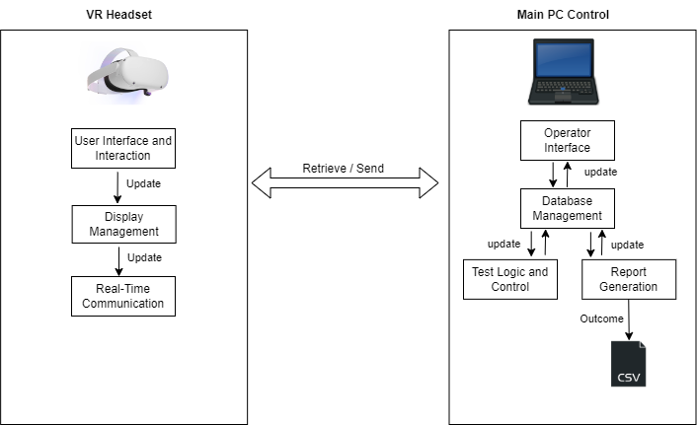Figure 8: VR and Computer Architecture

VR Headset

**1. User Interface and Interaction:**

-Manages the detection and processing of user inputs through VR controllers or other input devices

- Tracks and records the subject's physical movements like navigating, selections, and interactions within the virtual environment.

- Captures responses when the subject interacts with the mock smartphone, identifying images and selecting products.

**2.Display Management**

**-** exhibit the virtual supermarket asset where the test is conducted.

- Displays videos, images, and instructions to the subject during various phases of the test

**3. Real-Time Communication:**

- Sends real-time data about the subject’s movements and choices to the main PC.

- Receives updates or changes in the test parameters from the PC(e.g., navigation paths, product locations).

PC Control side-

**1. Operator Interface:**

- Web-based application allowing the operator to input and manage subject details.

- Enables the operator to monitor the test progress in real-time and intervene if necessary.

- Allows for viewing and exporting the results of the test sessions.

**2. Database Management:**

- Stores all relevant data including subject serial number, test parameters, results, time,and the image library for recognition tasks.

- Ensures data integrity and provides necessary data to both the operator and the VR application as required.

- The system will not store any personal details for reasons of security and medical confidentiality.

**3. Test Logic and Control:**

- Manages the logic for simulation setup, test execution, and transitions between phases.

- Controls the parameters of the test based on operator inputs and sends these updates to the VR headset.

- embedding images of family members into the subjects screen from the operator's screen.

**4. Report Generation:**

- Analyzes collected data to evaluate metrics like route efficiency ,performance, recognition accuracy and evaluating response times.

- Generates reports and CSV files for detailed post-test analysis by the specialist.

**Interaction Flow:**

* **Initialization:** Before starting the test, the operator inputs the subject’s serial number into the Main PC Control and configures the initial test environment based on the planned setup to the VR headset.
* **During the Test:** The VR headset sends real-time data about the user's movements and responses to the Main PC Control. The control unit processes this data, updates test conditions as necessary. Additionally, it sends the user's interaction data to the operator interface, allowing the operator to track progress and take notes on the measured variables of the test.
* **Post-Test:** The Main PC Control processes and compiles the test results into a CSV file, This file is then accessible via the operator interface for further review and analysis.

## The VR application

A typical Unity3D-built VR application handles the well-known Model View Controller (MVC) architecture. That's exactly what the figure below illustrates.

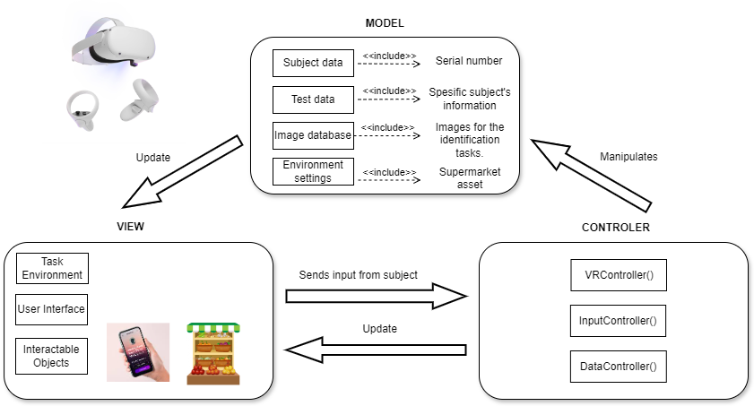

Figure 9: Model-View-Controller (MVC) architecture

**Model**

The Model represents the application's dynamic data structure, independent of the user interface. It directly manages the data, logic, and rules of the application.

**Subject Data:** Includes details about the user such as their serial number.

**Test Data:** Stores information about the specific test, like product locations, optimal routes, and task configurations.

**Image Database**: Contains the images for the identification tasks.

**Environment Settings:** All settings related to the virtual supermarket.

**View**

The View displays the data (the model) to the user and sends user commands (events) to the controller. It represents the VR interface as seen and interacted with by the user.

**VR Environment**: Visual representation of the supermarket asset.

**User Interface**: Includes menus, instructional videos, and real-time feedback or prompts that appear in the VR environment.

**Interactable Objects**: Items that the user can interact with, like virtual products on shelves or a simulated smartphone.

**Controller**

The Controller acts upon both model and view. It controls the data flow into model objects and updates the view whenever data changes.

**VRController**: Manages the app states, such as transitions between setup, instruction, testing, and results phases., and handles interactions between the View and Model.

**InputController**: Handles user input from VR controllers, transforming movements and button presses into VR activities.

**DataController**: Manages interactions with the server to retrieve and update models based on user interactions and test results.

# Input Output Tests

The following table describes input output scenarios. There are 4 main cases with different output scenarios. The desired output consists both visual and invisible counters.

|  |  |  |
| --- | --- | --- |
| **case** | **input** | **output** |
| returning to the same intersection. | Avatar appear every intersection only once. | Intersection counter is 0. |
| Avatar appear every intersection more than once. | Increment intersection counter. |
| Phone ringing | the subject recognizes his relative | Mark the field and don’t ring the phone again. |
| the subject does not recognize his relative | Ringing counter increment.  Ring again. |
| The phone rings only 3 times. |  |
| the subject becomes confused after picking up the phone | Avatar change his direction up to 90 degrees. | noting |
| Avatar change his direction up to 90 degrees. | Count |
| Selecting a product | Selecting the correct product | Finish the Test. End massage appear. |
| Selecting the wrong product | Increment selecting counter and ask the subject to try again. |

Table 1: Tests

## System Evaluations

Our goal is to assess the system's efficacy by testing it on two groups: verified Alzheimer's disease (AD) patients and unverified patients. This evaluation aims to ascertain the system's ability to identify potential cases of Alzheimer's disease. By comparing the system's performance between these two groups, we can gauge its accuracy in detecting the presence of AD based on predefined criteria or indicators. This approach allows us to evaluate the system's sensitivity and specificity in distinguishing individuals with AD from those without, thereby providing valuable insights into its diagnostic capabilities and potential utility in clinical settings.

# References

[1] Livingston, G., Huntley, J., Sommerlad, A., Ames, D., Ballard, C., Banerjee, S., ... & Mukadam, N. (2020). Dementia prevention, intervention, and care: 2020 report of the Lancet Commission. *The Lancet*, *396*(10248), 413-446.

[2] Wimo, A., Guerchet, M., Ali, G. C., Wu, Y. T., Prina, A. M., Winblad, B., ... & Prince, M. (2017). The worldwide costs of dementia 2015 and comparisons with 2010. *Alzheimer's & Dementia*, *13*(1), 1-7.

[3] Prince, M., Wimo, A., Guerchet, M., Ali, G. C., Wu, Y. T., & Prina, M. (2015). World Alzheimer report 2015. The global impact of dementia: an analysis of prevalence, incidence, cost and trends (Doctoral dissertation, Alzheimer's disease international).

[4] Evenson, G. R., Golden, H. E., Lane, C. R., McLaughlin, D. L., & D'Amico, E. (2018). Depressional wetlands affect watershed hydrological, biogeochemical, and ecological functions. *Ecological Applications*, *28*(4), 953-966.

[5] Gorelick, P. B., Scuteri, A., Black, S. E., DeCarli, C., Greenberg, S. M., Iadecola, C., ... & Seshadri, S. (2011). Vascular contributions to cognitive impairment and dementia: a statement for healthcare professionals from the American Heart Association/American Stroke Association. *stroke*, *42*(9), 2672-2713.

[6] [Mayo Clinic. (2023). Alzheimer's disease - Diagnosis and treatment](https://www.mayoclinic.org/diseases-conditions/alzheimers-disease/diagnosis-treatment/drc-20350453).

[7] Parizkova, M., Lerch, O., Moffat, S. D., Andel, R., Mazancova, A. F., Nedelska, Z., ... & Laczó, J. (2018). The effect of Alzheimer's disease on spatial navigation strategies. Neurobiology of Aging, 64, 107-115.‏

[8] Montenegro, J. M. F., & Argyriou, V. (2017). Cognitive evaluation for the diagnosis of Alzheimer's disease based on turing test and virtual environments. *Physiology & behavior*, *173*, 42-51.‏

[9] Puthusseryppady, V., Morrissey, S., Spiers, H., Patel, M., & Hornberger, M. (2022). Predicting real world spatial disorientation in Alzheimer’s disease patients using virtual reality navigation tests. Scientific Reports, 12(1), 13397.

[10] McKhann, G. M., Knopman, D. S., Chertkow, H., Hyman, B. T., Jack Jr, C. R., Kawas, C. H., ... & Phelps, C. H. (2011). The diagnosis of dementia due to Alzheimer’s disease: Recommendations from the National Institute on Aging-Alzheimer’s Association workgroups on diagnostic guidelines for Alzheimer's disease. Alzheimer's & dementia, 7(3), 263-269.,

[11] Clay, F., Howett, D., FitzGerald, J., Fletcher, P., Chan, D., & Price, A. (2020). Use of immersive virtual reality in the assessment and treatment of Alzheimer’s disease: A systematic review. *Journal of Alzheimer's Disease*, *75*(1), 23-43.

[12] Zygouris, Stelios et al. ‘Usability of the Virtual Supermarket Test for Older Adults with and Without Cognitive Impairment’. 1 Jan. 2022 : 229 – 234.

[13]Zakzanis, K. K., Quintin, G., Graham, S. J., & Mraz, R. (2009). Age and dementia related differences in spatial navigation within an immersive virtual environment. *Medical Science Monitor*, *15*(4), CR140-CR150

[14] Tu, S., Wong, S., Hodges, J. R., Irish, M., Piguet, O., & Hornberger, M. (2015). Lost in spatial translation–A novel tool to objectively assess spatial disorientation in Alzheimer's disease and frontotemporal dementia. Cortex, 67, 83-94.